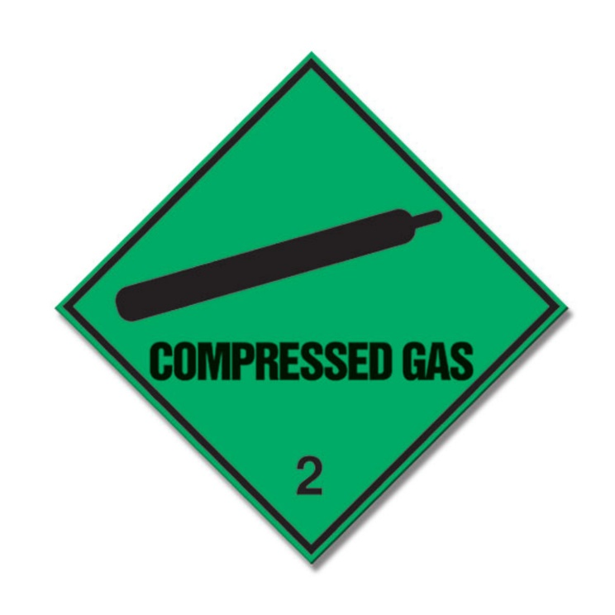
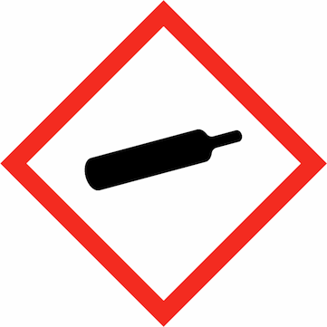
CAUTION
COMPRESSED GAS CYLINDERS IN USE!

Date: |  | Room/Lab Number: |  | EMERGENCY CONTACTS  Please write legibly!
Location in room/lab:
Gas type: | Helium | Cylinder size:
Symbols: | 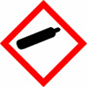  GHS04 | Blank | Blank | SUPERVISOR
 |  |  |  | TEL
 |  |  |  | PERSON 1
 |  |  |  | TEL
 |  |  |  | PERSON 2
Signal Word: | WARNING |  |  | TEL
Hazard Statements: | H280 | Precautionary Statements: | P410 + P403 | Further Notes
Used for:
Student name: |  | Supervisor name:
Student Signature: |  | Supervisor Signature:
SCHOOL OF CHEMISTRY

